Theory 3 – Kingdoms
Plantae

Animalia

Fungi

Monera

Protista

Classifying cells of the kingdoms

Organism A
Key to the five kingdoms
Level 1
1a. Cells have a nucleus …..........…. Go to level 2
1b. No nucleus ……………………………..… BACTERIA

Level 2
2a. Multicellular ……...................…. Go to level 3
2b. Single cell………………………..………... PROTISTS

Level 3
3a. Can’t use the sun’s energy …............PLANTS
3b. Uses the sun for nutrients........ Go to level 4

Level 4
4a. Cells have a cell wall…………..…. Go to level 2
4b. No cell wall …………………………….…. ANIMALS

This organism has cells with a nucleus and a cell wall. It is multicellular and can use the sun to gain nutrients.
This organism belongs to the ___________________ kingdom

Organism B
This organism has cells with a nucleus but no cell wall. It only exists as a single cell and uses the sun to get nutrients.
This organism belongs to the ___________________ kingdom

Organism C
This organism has cells without a nucleus but it has a cell wall. It is a single celled organism and uses the sun for nutrients.
This organism belongs to the ___________________ kingdom

Organism D
This organism has cells with a nucleus and but doesn’t have a cell wall. It is multicellular and needs to find its own food.
This organism belongs to the ___________________ kingdom

Organism E
This organism has cells with a nucleus and a cell wall. It is multicellular and can’t use the energy from the sun for nutrients.
This organism belongs to the ___________________ kingdom

Organism F
This organism can’t use the energy from the sun and is a multicellular organism. The cells don’t have cell walls.
This organism belongs to the ___________________ kingdom

Make your own dichotomous key

Title: Key to Identifying ____________________ Go To:
Step 1 | 1a.
 | 1b.
Step 2 | 2a.
Step 2 | 2b.
Step 3 | 3a.
 | 3b.
Step 4 | 4a.
 | 4b.
Step 5 | 5a.
 | 5b.
Step 6 | 6a.
 | 6b.
Step 7 | 7a.
 | 7b.
Step 8 | 8a.
 | 8b.

A | 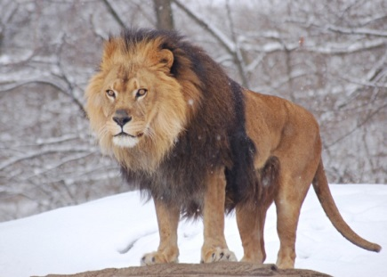
B | 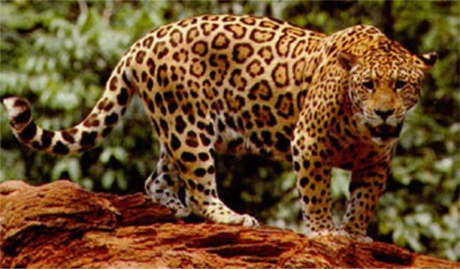
C | 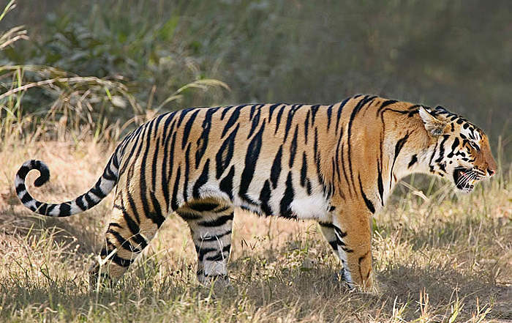
D | 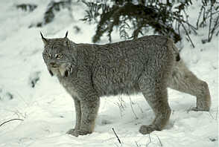
E | 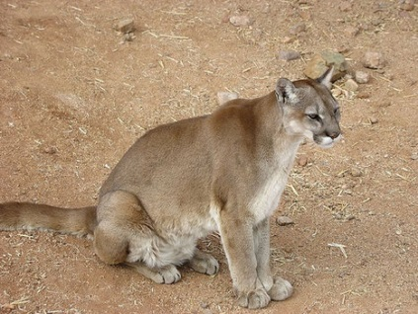
F | 